Orange Shirt Day
September 30, 2013
September 30th has been declared Orange Shirt Day annually, in recognition of the harm the residential school system did to children's sense of self-esteem and wellbeing, and as an affirmation of our commitment to ensure that everyone around us matters.

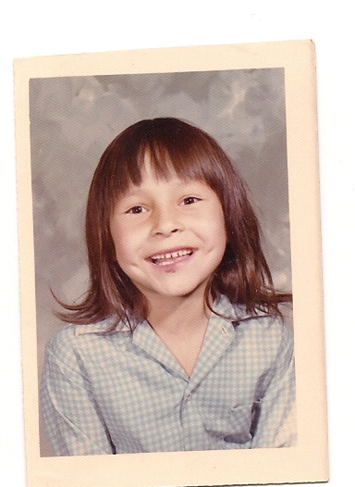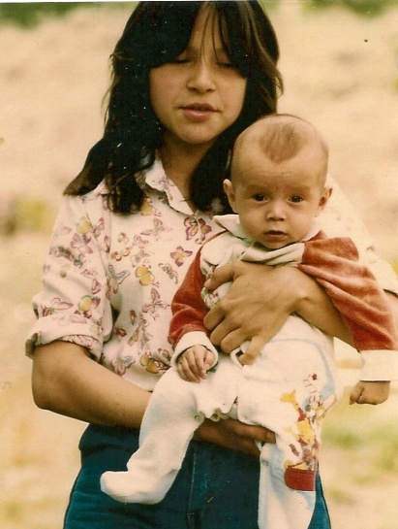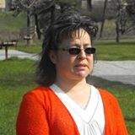
Phyllis (Jack) Webstad
Phyllis’ Story
I went to the Mission for one school year in 1973/1974. I had just turned 6 years old. I lived with my grandmother on the Dog Creek reserve. We never had very much money, and there was no welfare, but somehow my granny managed to buy me a new outfit to go to the Mission school. I remember going to Robinson’s store and picking out a shiny orange shirt. It had string laced up in front, and was so bright and exciting – just like I felt to be going to school! When I got to the Mission, they stripped me, and took away my clothes, including the orange shirt! I never saw it again. I didn’t understand why they wouldn’t give it back to me, it was mine! The color orange has always reminded me of that and how my feelings didn’t matter, how no one cared and how I felt like I was worth nothing. All of us little children were crying and no one cared.
I was 13.8 years old and in grade 8 when my son Jeremy was born. Because my grandmother and mother both attended residential school for 10 years each, I never knew what a parent was supposed to be like. With the help of my aunt, Agness Jack, I was able to raise my son and have him know me as his mother.
I went to a treatment centre for healing when I was 27 and have been on this healing journey since then. I finally get it, that the feeling of worthlessness and insignificance, ingrained in me from my first day at the mission, affected the way I lived my life for many years. Even now, when I know nothing could be further than the truth, I still sometimes feel that I don’t matter. Even with all the work I’ve done!
I am honored to be able to tell my story so that others may benefit and understand, and maybe other survivors will feel comfortable enough to share their stories.

Today

Phyllis is married, has one son and two grandsons aged nine and five years old. She is Northern Secwepemc (Shuswap) from the Stswecem’c Xgat’tem First Nation (Canoe Creek Indian Band). She comes from mixed Secwepemc and Irish/French heritage, was born in Dog Creek, and lives in Williams Lake, BC.

She earned diplomas in Business Administration from the Nicola Valley Institute of Technology; and in Accounting from Thompson Rivers University.

